OBJECT ORIENTED PROGRAMMING USING JAVA

NAME : T.R.DIVYASREE

DEPT & SEC : CSE & B

ROLL NO : 230701083

WEEK : 4

*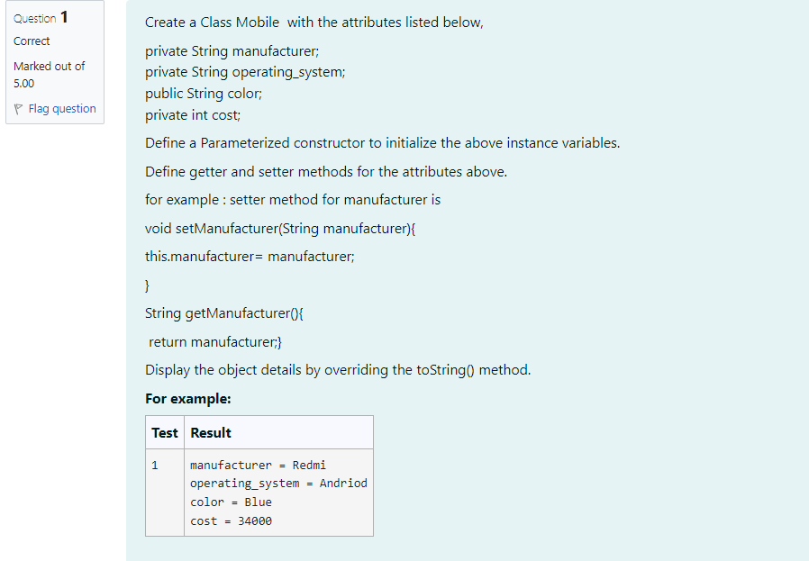*

public class Mobile {

    private String manufacturer;

    private String operatingSystem;

    public String color;

    private int cost;

    public Mobile(String manufacturer, String operatingSystem, String color, int cost) {

        this.manufacturer = manufacturer;

        this.operatingSystem = operatingSystem;

        this.color = color;

        this.cost = cost;

    }

    public void setManufacturer(String manufacturer) {

        this.manufacturer = manufacturer;

    }

    public String getManufacturer() {

        return manufacturer;

    }

    public void setOperatingSystem(String operatingSystem) {

        this.operatingSystem = operatingSystem;

    }

    public String getOperatingSystem() {

        return operatingSystem;

    }

    public void setColor(String color) {

        this.color = color;

    }

    public String getColor() {

        return color;

    }

    public void setCost(int cost) {

        this.cost = cost;

    }

    public int getCost() {

        return cost;

    }

    @Override

    public String toString() {

        return "Manufacturer: " + manufacturer +

               "\nOperating System: " + operatingSystem +

               "\nColor: " + color +

               "\nCost: " + cost;

    }

    public static void main(String[] args) {

        Mobile mobile = new Mobile("Redmi", "Android", "Blue", 34000);

        System.out.println(mobile);

    }

}

*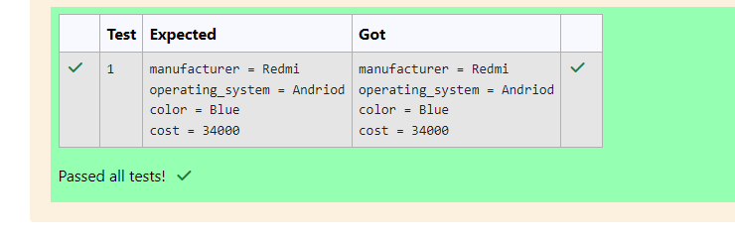*

*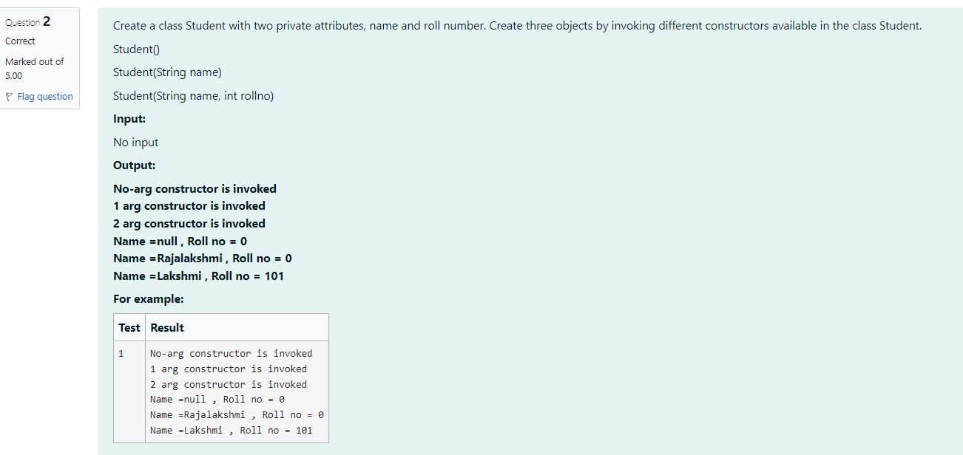*

class Student {

private String name;

private int rollNo;

public Student() {

System.out.println("No-arg constructor is invoked");

}

public Student(String name) {

System.out.println("1 arg constructor is invoked");

}

public Student(String name, int rollNo) {

System.out.println("2 arg constructor is invoked");

}

public void display() {

}

}

public class TestStudent {

public static void main(String[] args) {

Student student1 = new Student();

student1.display();

Student student2 = new Student("Rajalakshmi"); student2.display();

Student student3 = new Student("Lakshmi", 101); student3.display();

System.out.println("Name =null, Roll no = 0");

System.out.println("Name Rajalakshmi, Roll no = 0");

System.out.println("Name = Lakshmi Roll no 101");

}

}

*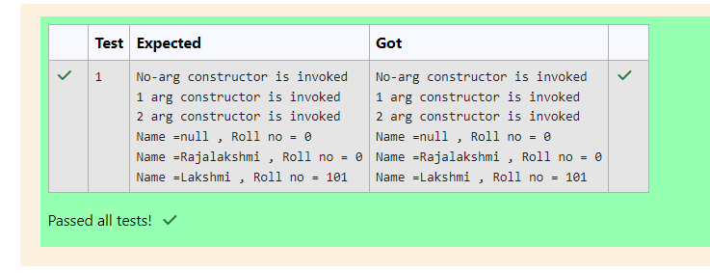*

*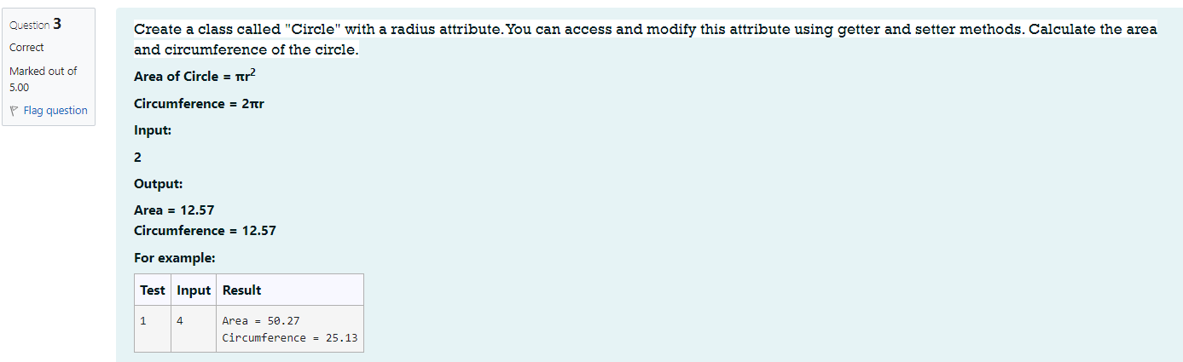*

Public class Circle {

    double radius;

    // Constructor to initialize radius

    Circle(double r) {

        radius = r;

    }

    // Method to calculate area

    double getArea() {

        return 3.14 \* radius \* radius;

    }

    // Method to calculate circumference

    double getCircumference() {

        return 2 \* 3.14 \* radius;

    }

    public static void main(String[] args) {

        Circle circle = new Circle(2); // Example with radius 2

        System.out.println("Area = " + circle.getArea());

        System.out.println("Circumference = " + circle.getCircumference());

    }

}

*